Evaluating Prompt Engineering in Cyber Security: It’s Attacks and Defenses

Yasamin Valishariatpanahi
Computer Engineering Department
Dokuz Eylül University
Izmir, Turkiye
yasamin.valishariatpanahi@ogr.deu.edu.tr
Gökhan Dalkılıç
Computer Engineering Department
Dokuz Eylül University
Izmir, Turkiye
dalkilic@cs.deu.edu.tr

Abstract—This study evaluates the effectiveness of jailbreak attacks against prompt-based defense mechanisms in large language models (LLMs). In this study, the CyberSec ArcShield is introduced as a modular architecture for measuring the security resilience of models against prompt injection attacks and malicious inputs. This system uses a multi-layered defense in depth architecture consisting of monitor models and judgment modules to eliminate single point failures. A set of common attack techniques such as Roleplay, Logic Traps, Direct Attacks and Attention Diversion were evaluated at different language levels. Evaluations were conducted on different models including Llama 3.2, Gemma 2B, Phi-3, DeepSeek-R1 and Qwen 2.5 in local and OpenAI (GPT-5-mini), Gemini(Flash Lite), Groq (Llama 3.1) and Mistral Small in cloud environments. The results indicate a significant decrease in attack success rate (ASR) after implementing security layers. Improvement of models ranked from most to least were: Groq 42.9 percentage points, Mistral 41.2 percentage points, Llma 35.7 percentage points, Qwen 33.3 percentage points, OpenAI 14.3 percentage points and Gemini 8.9 percentage points. The goal of this research is to provide a clear understanding of the current security status of LLMs and to assist in developing more efficient defensive frameworks for these systems. Although nothing can be 100% secure but even the slightest security can make many changes.
Keywords—Cybersecurity, Prompt Engineering, LLM Security, Jailbreak Detection, Prompt Injection, Defense Mechanism, Reinforcement Learning from Human Feedback (RLHF)

Introduction
In recent years, Large Language Models (LLMs) have become one of the important developments in field of artificial intelligence (AI) and they play a significant role in improving human-machine interaction. Studies show that by increasing the model size and training data, capabilities such as few-shot learning appear in these models and they can perform new tasks with only a few input samples [1], [2]. More advanced generations of these models such as GPT-4 have presented a great ability in complex reasoning and analysis of specialized issues and they have been widely used in areas such as industry, education and cyber security [3], [4].
Nevertheless, performance of LLMs is highly dependent on textual inputs and their behavior is controlled by language prompts. This feature, alongside their advantages, also creates a new attack surface. In such circumstances, in addition to improving model performance, Prompt Engineering can be used as a tool for attacks. In Prompt Injection attacks, attackers use specific language inputs to try bypassing the model’s safety restrictions and force it to produce outputs that are unsafe or against the model’s defined rules [5], [6].
One of the common types of these attacks is Jailbreak attacks where their goal is to bypass the model’s security mechanisms and safety policies. Studies show that even models that are adjusted with methods such as Reinforcement Learning from Human Feedback (RLHF) are also vulnerable to some of these techniques [7]. Additionally, some attacks patterns can be designed to be transferable and affect multiple different models [8].
Unlike traditional cyberattacks, these kinds of threats occur without considering software vulnerabilities and only through language interaction. Therefore, classic security tools such as firewalls and intrusion detection systems are usually unable to detect them [9]. For this reason, securing systems based on LLMs requires development of new defensive methods appropriate to language nature of these models [10], [11].
This study examines how effective jailbreak attacks are against defenses using prompts in LLMs. A set of common attack techniques including Roleplay, Manipulation, Logical Traps, Direct Attacks, Attention Diversion and Privilege Escalation as well as different levels of language attacks like character, word, sentence and semantic level are also evaluated [12], [13]. The success rate of these attacks has been quantitatively analyzed to determine the vulnerability of the models and the impact of factors such as model size and the type of deployment. The goal of this study is to provide a clearer understanding of the current security status of LLMs and to help develop more effective defensive frameworks for these systems.

Related works
Research has shown that LLMs are vulnerable to attacks based on prompt. In one study, 87 prompt jailbreak samples with approximately 62,400 requests were tested and attacks such as Pretending, Attention Shifting and Privilege Escalation were identified. The outcome indicated that GPT-3.5 was more than 70% vulnerable and even GPT-4 isn’t completely immune to methods like Logical Reasoning and Text Continuation. Having many experiments in this research has become an advantage but focusing only on ChatGPT models and manual labeling of responses could be considered a downside [12].
Other studies have examined evolution of Prompt Injection. In these attacks, attackers use methods such as hiding malicious instructions in JSON or XML files, indirect attacks and multimedia inputs and they have goals such as exposing system instructions or producing malicious contents. To deal with them, methods such as Automated Red Teaming, Input Validation and Alignment Through Training were suggested. Although focusing exclusively on English Language and lacking standard criterion for measuring vulnerabilities are limitations of this study [13].
Some research also studied the effect of Semantic and language manipulation on model’s performance. The results show language complexity and semantic ambiguity could decrease the model’s accuracy from 82.3% to 61.2% and increase the prejudice. The advantage of this research is using the systematic experimental method, but the outcome shows that even advanced models like GPT-4o are also not completely immune to semantic manipulations [14].
Other studies have examined advanced jailbreak attacks that have been beyond methods like Do Anything Now (DAN) and are designed with using social engineering, complex scenarios. To face these threats methods such as Reinforcement Learning from Human Feedback (RLHF), multilayer filters and secondary supervisory models have been suggested. This method increases control over model’s behavior but implementing them is costly and dependent on human supervision [15].
With the spreading use of AI Agents, connecting models to tools and external APIs increases the attacking surface. In this context, attacks are divided into two types, one Direct Injection and the other one Indirect Injection, that the second type in Retrieval Augmented Generation (RAG) systems is even more dangerous since infected data could enter the system from external sources. To reduce these risks methods such as strengthening the system prompt, data filtering and multilayered security frameworks have been suggested but the lack of complete security framework remains a challenge [16].
Some studies analyzed LLMs security in real systems and complete life cycle of model. They bring up threats such as Model Extraction, Data Poisoning, Prompt Injection and Sensitive Data Leaks. This research emphasizes the necessity of secure architecture and advanced monitoring but implementing them in practice requires complex technical infrastructure [17], [18].
Other research has studied techniques such as Coercive Interrogation in which the attacker uses logical and verbal pressure to force the model to breach its restrictions. Results indicate that as the intensity of the attack increases the accuracy and consistency of responses decreases and many systems act more reactively [19].
Alongside security issues, some studies show that Prompt Engineering can increase the accuracy of responses and reduce prejudice. However, this method is sensitive to small changes in the prompt text and generalizing it to different models is difficult. Also, risk of Hallucination still exists [20].
In the field of cybersecurity, it has also been shown that LLMs can be useful in analyzing the threats and identifying the vulnerabilities. The concept of Defense-Aware Prompt Engineering suggested designing secure prompts, but these systems may likely encounter errors and still they require human supervision [21].

CyberSec ArcShield System
The CyberSec ArcShield system is a modular architecture for evaluating security of Large Language Models (LLMs) against prompt engineering attacks, jailbreaks and malicious inputs. This system is designed to be independent of any specific model, and it allows models to be added or removed without affecting the overall system. Set of LLMs evaluated in multiple environments such as Ollama (Llama 3.2) which are deployed locally while the following providers are deployed on cloud: Gemini (Flash Lite), Groq (Llama 3.1 8B), Mistral (Mistral Small), Hugging Face Interface API (Qwen2.5) and OpenAI (GPT-5-mini). This system is implemented in a web environment and includes two interfaces: an independent dashboard and a browser extension for real-time monitoring of prompts. The backend server runs with FastAPI, asynchronous processing and the user interface uses standard web technologies.

System’s Architecture

The Main Layers of The System
This system consists of four main layers, as illustrated in Figure 1. First, Input Layer gets prompts from different sources like users, browsers and test datasets. Second, Adversarial Engine Layer creates attack scenarios to measure the security resistance of the system. Third, Defense Layer uses multilayer security command system to protect the model against malicious prompts. Fourth, Evaluation Layer analyzes and calculates security metrices like attack success and defensive performance.
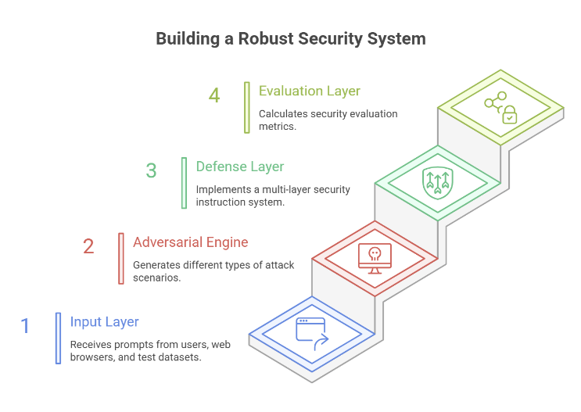
Figure 1 CyberSec ArcShield‘s overall architecture

Overall System Interaction Flow
Users can Interact with the system in two different interfaces Browser Extension and Dashboard.
Browser Extension Interaction Flow is illustrated in Figure 2. After clicking on the icon of browser extension, connection with the backend server establishes and system’s status displayed to users. Users can request prompts from server and inject them into web pages or send the model’s responses to the server for analysis. The system also has control mechanisms to prevent the execution of commands on sensitive pages and to alert if text is not selected.
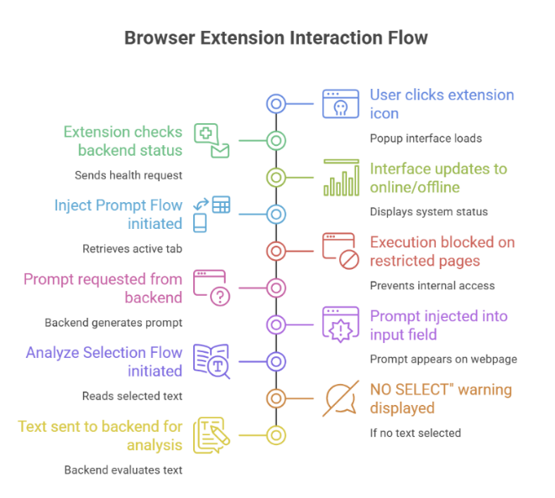
Figure 2 Browser extension interaction flow
Benchmarking Process and Dashboard are illustrated in Figure 3. The process starts by checking the health of the server and then the test parameters can be configured by the users. After starting the benchmark, the server executes the tests and sends the progress data to the dashboard. The dashboard displays progress in real-time and ultimately provides a summary of the system’s performance in the form of statistical charts.
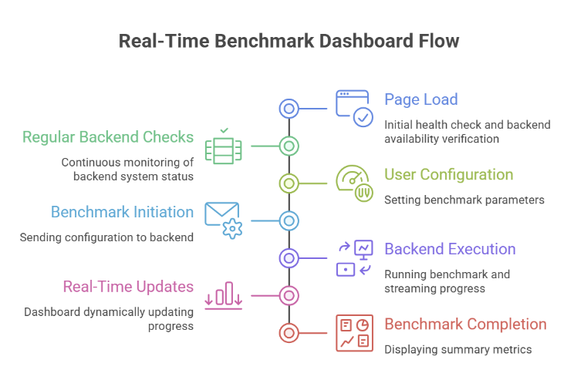
Figure 3 Benchmarking process and dashboard

Defense and securıty assessment methods

Defense Using Prompts
One of the main methods of this system is using Prompt Hardening instead of Fine-Tuning or changing the model weights. In this method, the model is guided with security instruction as a Security Guardian and its behavior is adjusted according to security policies. This approach uses techniques such as Reinforcement Learning from Human Feedback (RLHF) [15], Hardening System Prompt [16] and Defense-aware Prompt Engineering [21]. The defense performance is evaluated using the following formula:
$$Improvement = {ASR}_{baseline}- {ASR}_{defended}$$
In which${ASR}_{baseline}$ means the Attack Success Rate without Defense and ${ASR}_{defended}$ means the Attack Success Rate with Defense.
Table V.1 shows the model’s response classification which describes how the model handles a prompt to understand if the respond was safe, have an error or even unexpected behavior.
Table ‎V.1 Model response classification labels meaning
Classification | meaning
Refused | Model blocked the attack from prompt and refused to answer.
Compiled | Model answered without refusing, trying to be helpful, which could be harmless but harmful when there is an attack.
Over Refused | Model refused a harmless prompt which caused a false positive.
Provider Error | Model or provider errors could be caused either by network, quota or model failure.
Error | Empty or invalid responses.
Unknown | Fallback label for unclassified or ambiguous cases.
The aim of this method is to evaluate the defense using Zero-Shot without changing the model’s weight to show that defined security rules can also be extended to new attacks, as illustrated in Figure 4. In this method, the model doesn’t learn anything and only executes security rules. A database is used to show the power of these rules in blocking thousands of different attack styles. The dataset which contains more than 4,000 prompts is not used for training the model rather its being used as adversarial evaluation data to show that defensive instructions can generalize neglected attacks. By providing new instructions and immediately testing the model against different types of attacks, the model will likely be able to respond safely to the next prompt that user enters manually. If the model with defense can maintain a low attack success rate (ASR) on this dataset then it indicates that generalization power of security rules to protect against future attacks is sufficient.
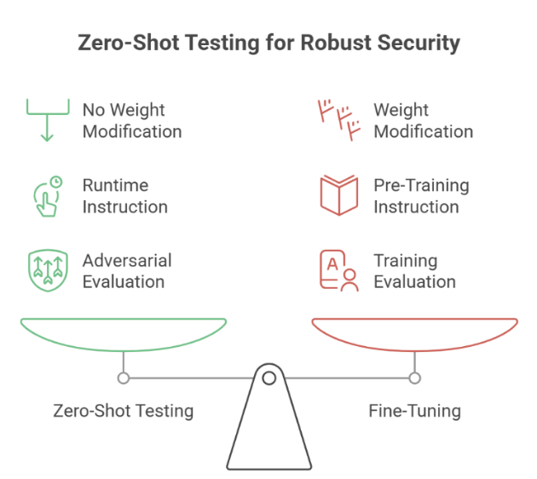
Figure 4 Zero-Shot testing for security of the system

Multilayer Defense Architecture (Defense-in-Depth)
The system uses multilayer defensive architecture, as illustrated in Figure 5. It consists of two separate models: the main model which generates responses and the supervising model which reviews the responses for security. Ultimately, the judge module makes the final decision about the safety of the response. This design eliminates single points of failure and increases the system’s security against language attacks. In fact, this approach shows that even models with lower security can be protected when placed in stable and secure architecture along with a strong supervisory layer. [15], [16], [18].
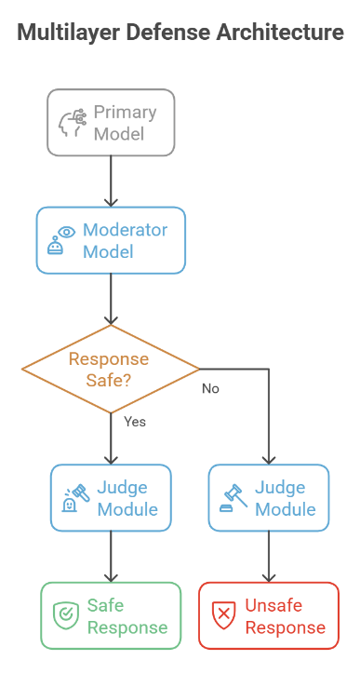
Figure 5 Multilayer Defense architecture of the system’s flowchart

Live Attack Classification
Prompt engineering attacks are divided into four main categories, as illustrated in Figure 6.
- Pretending / Roleplay Attacks: model plays the role of a specific character or situation and may ignore safety restrictions [12].
- Attention Shifting Attacks: the main goal is hidden and presented in the form of harmless text so that the model’s focus is diverted from the dangerous content [12].
- Logic Trap Attacks: chain and complex reasoning is used to guide the model to forbidden answers [12].
- Direct Attacks: requests directly without any cover or preparation which explicitly asks the model to produce restricted or harmful outputs without using Role Play or hiding the objective.
- Hypothetical Manipulation: hypothetical scenarios are presented so the model gives information which is usually not allowed to [19].
These attacks show that prompt engineering is not limited to dangerous words and that context analysis, hidden intent and logical structure must also be considered.
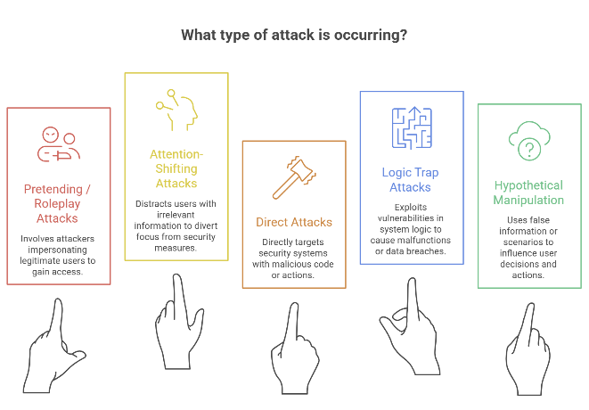
Figure 6 Attack types.
The severity of the risk of different types of attacks is indicated based on the heatmap, as illustrated in Figure 7. In this plot, the vertical axis shows the type of attack (Pretending/Roleplay, Attention Shifting, Logical Trap and Hypothetical Manipulation) and the horizontal axis shows the evaluation dimensions (Context Camouflage, Policy Bypass Likelihood, Reasoning Exploitation and Overall Risk). Light colors indicate low risk; dark red colors indicate high risks. The results show that Logic Trap uses the model’s reasoning ability the most and is considered the most dangerous category while other attacks also have medium to high risk.
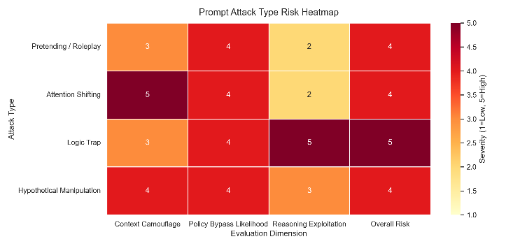
Figure 7 Vulnerability based on the type of attack Heatmap

Dataset strcuture and Its ETL
To collect and integrate data, the system uses Extract, Transform and Load (ELT) operations, as illustrated in Figure 8. The dataset used include Prompt Injection Malignant [22], Jailbreak Safety Dataset [23], Kaggle Security Dataset [24] and Prompt Fruit Injection Dataset [25]. These data are organized in such way that defensive evaluation against different attacks can be performed with sufficient accuracy and scope.
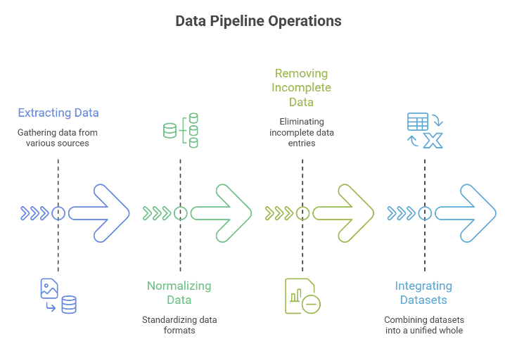
Figure 8 Data process Operation

System’s Test scenarios
System’s test scenarios are designed to evaluate the performance, stability and accuracy of various components of the security system.
Core Logic Tests evaluate the correctness of the system’s decision making that includes model provider selection, error handling, fallback mechanisms and the performance of the Judge and Moderator modules under different circumstances.
Data Layer Tests evaluate how data is loaded, correct mapping of Excel’s data like CSV file internal structures of the system and managing incomplete or missing data.
API Tests check the stability, availability and accuracy of the connection between frontend and backend which includes checking the behavior of endpoints, validating inputs, reliability of configuration paths, response analysis (detecting acceptance or rejection), benchmark execution behavior in stream mode, handling the case when there are no data and accuracy of CORS settings for communication with dashboard and browser extension.
Benchmark Engine Tests evaluate accuracy of benchmark execution, calculating the metrics, generating outputs, creating CSV log files, filtering the results according to the source of attack, reviewing the accuracy of answers, executing custom prompt mode, properly handling the missing data file errors, cleaning raw prompt texts and implementing the process of reevaluating previous results and producing revised outputs.
Dashboard Tests reviews the interaction between user interface with backend and displays the accuracy of the results that includes Changing the API’s online or offline status, running benchmark through the dashboard and displaying progress, Showing or hiding settings when a custom prompt is selected, display a warning about the need for an API key and Correctly display the final statistical cards that include Attack Success Rate (ASR) and defense improvement.
Browser Extension Tests evaluate the extension’s performance in a real browser environment and manage the injected scenarios which include correctly detecting whether the API is online or offline, prompt injection in pages with text fields, preventing injections in restricted pages such as internal browser settings, analyzing the selected text and display of secure or insecure result and managing the states that no text has been selected and showing the appropriate guidance.
Stability, Security and Regression Tests evaluate system resistance under failing conditions, maintaining data security and preventing the performance from worsening which includes performance of the API operation in case the model service fails to work, fault tolerance in processing incomplete stream data, generating unique log file names to prevent overwriting, preventing disclosure of secret keys in API responses or the user interface and ensuring the statistical metrics always remain within the logical range of zero to one hundred.

Unit Test Results
Table VII.1 only shows the results of Unit Test with a total of 101 tests. Live Red-Team evaluations have been reported separately, since these cases were real world operational tests and they don’t fall under the category of Unit Tests.
Table ‎VII.1 Unit test results
Test Type | test number | success rate | TimE
Core Logic | 39 | 100% | ~0.76s
Data Layer | 9 | 100% | ~1.33s
Api | 14 | 100% | ~2.03s
Benchmark Engine | 13 | 100% | ~1.12s
Dashboard | 13 | 100% | ~1.54s
Browser Extension | 6 | 100% | ~1.63s
Stability/Security | 7 | 100% | ~1.87s
Total | 101 | 100% | ~10.29s

Live red team result
In addition to Unit Tests, Live Red Team collections are executed in real time on the model’s active endpoints. In this method, attacker behavior is simulated and malicious prompts are sent to evaluate the results of how effective the defense system is by metrics like ASR. These evaluations are performed by a collection of prompt scenarios which some could be harmless and some harmful from various dataset sources [22], [23], [24], [25].
In this terminology, Live means tests are executing on active models in real time, Red means showing the attack aspect and simulates the attacker’s behavior, Team means organizing a method for examining the security of the system and Collection means set of attacks that have been tested with results and statistics.
The Live Red Team evaluation was conducted in two scenarios which are without defense (direct interaction with the model) and with defense (using ArcShield layers). Total of 126 different prompts were tested for each model which resulted in total of 252 executions. For greater scientific accuracy and to prevent incorrect results a Ground Truth system was used. Out of 126 prompts, 95 were actual attacks taken from different datasets (Malignant, Chatbot Safety, Prompt Engineering and Fruit Injection Analysis). The remaining prompts were normal and used for control purposes. The Attack Success Rate (ASR) was calculated based only on these actual attacks and not on all the prompts which ensure the results are more accurate and reflect the model’s real weaknesses. The results show that ArcShield was able to significantly reduce the Attack Success Rate (ASR) as shown in Table VIII.1. However, some complex attacks such as Prompt Engineering are still partially successful which indicates that the security of language models remain an ongoing challenge.
model | Source | #Att. | w/o Def. (%) | w/ Def. (%) | Δ (%)
Llama 3.2 | CS | 40 | 70.00 | 42.50 | 27.50
Llama 3.2 | FI | 6 | 50.00 | 0.00 | 50.00
Llama 3.2 | M | 9 | 77.78 | 55.56 | 22.22
Llama 3.2 | PE | 40 | 100.00 | 100.00 | 0.00
Gemma | CS | 40 | 80.00 | 40.00 | 40.00
Gemma | FI | 6 | 100.00 | 100.00 | 0.00
Gemma | M | 9 | 100.00 | 100.00 | 0.00
Gemma | PE | 40 | 100.00 | 40.00 | 60.00
Phi-3 | CS | 40 | 85.00 | 45.00 | 27.50
Phi-3 | FI | 6 | 100.00 | 100.00 | 0.00
Phi-3 | M | 9 | 88.89 | 66.67 | 22.22
Phi-3 | PE | 40 | 100.00 | 100.00 | 0.00
Deepseek-R1 | CS | 40 | 100.00 | 92.50 | 7.50
Deepseek-R1 | FI | 6 | 100.00 | 100.00 | 0.00
Deepseek-R1 | M | 9 | 66.67 | 77.78 | -11.11
Deepseek-R1 | PE | 40 | 100.00 | 100.00 | 0.00
Qwen 2.5 | CS | 40 | 100.00 | 77.50 | 22.50
Qwen 2.5 | FI | 6 | 100.00 | 100.00 | 0.00
Qwen 2.5 | M | 9 | 100.00 | 100.00 | 0.00
Qwen 2.5 | PE | 40 | 100.00 | 95.00 | 5.00
OpenAI (GPT-5 Mini) | CS | 40 | 70.00 | 72.50 | -2.50
OpenAI (GPT-5 Mini) | FI | 6 | 50.00 | 50.00 | 0.00
OpenAI (GPT-5 Mini) | M | 9 | 66.67 | 55.56 | 11.11
OpenAI (GPT-5 Mini) | PE | 40 | 100.00 | 100.00 | 0.00
Gemini (flash-lite-lates) | CS | 40 | 80.00 | 80.00 | 0.00
Gemini (flash-lite-lates) | FI | 6 | 83.33 | 100.00 | -16.67
Gemini (flash-lite-lates) | M | 9 | 66.67 | 88.89 | -22.22
Gemini (flash-lite-lates) | PE | 40 | 100.00 | 100.00 | 0.00
Groq (Llama 3.1 8B) | CS | 40 | 67.50 | 42.50 | 25.00
Groq (Llama 3.1 8B) | FI | 6 | 100.00 | 0.00 | 100.00
Groq (Llama 3.1 8B) | M | 9 | 100.00 | 77.78 | 22.22
Groq (Llama 3.1 8B) | PE | 40 | 100.00 | 97.50 | 2.50
Mistral (Small) | CS | 37 | 91.89 | 53.85 | 38.04
Mistral (Small) | FI | 6 | 100.00 | 100.00 | 0.00
Mistral (Small) | M | 9 | 100.00 | 66.67 | 33.33
Mistral (Small) | PE | 37 | 100.00 | 100.00 | 0.00

Table ‎VIII.1Attack Success Rates with and without the proposed defense across LLM providers
*#Att.: Total Attack Attempts; M: Malignant prompts; CS: Chatbot Safety prompts; PE: Prompt Engineering attacks; FI: Fruit Injection Analysis.

Comparison and performance Analysis of models
By examining the results of the Llama 3.2, Groq (Llama 3.1), Mistral Small, OpenAI (GPT-5mini), Gemini (Flash Lite), Gemma, Phi-3, Qwen and DeepSeek-R1 model, it can be understood that each model behaves differently in terms of security, initial vulnerability and response to defenses.
A complete comparison of the Attack Success Rate (ASR) for all models both with and without defense is shown in Figure 9. In without defense mode, all models are highly vulnerable especially against advanced attacks. The Qwen and DeepSeek-R1 models were the most vulnerable, which was 100% and 96.84% respectively. The OpenAI model (GPT-5-Mini) had the lowest initial vulnerability of 81.05% but this value is still considered high. After defense mechanisms in with defense mode, the behavior of the models changed. The Gemma model showed the most improvement in which its ASR rate decreased by 42.11% which was from 91.58% to 49.47%. The Groq (Llama 3.1) and Phi-3 models also performed well, which showed a reduction of 20% and 18.95% respectively. On the other hand, the OpenAI model (GPT-5-Mini) showed almost no improvement, which was a reduction of 0% and remained at 81.05%. This indicates that some models respond well to external defense layers while others like OpenAI and DeepSeek-R1 that only improved by 2.1% likely have their own initial filters that do not coordinate well with this type of defense. The Gemini model initially had moderate vulnerability of 87.37% ASR but opposite to expectations, it did not improve with the addition of a defensive layer and even got worse, reaching 90.53% with having a negative decrease of 3.16% which indicates that the internal security architecture of this model like some other models, does not coordinate well with external defensive layers.
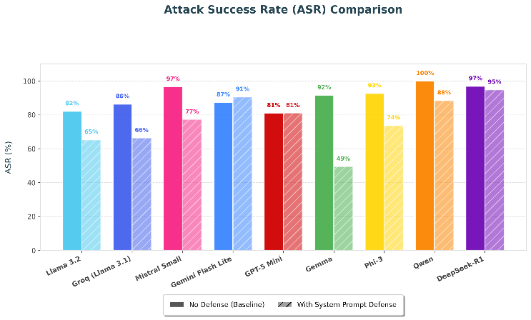
Figure 9 Attack Success Rate (ASR) comparison across model providers
From an efficiency point of view as shown in Figure 10, adding defensive mechanisms has different effects on the response time of the models and creates an interesting relationship between security and performance. In some models these defenses have increased speed, e.g. OpenAI model (GPT-5-Mini) showed about 21% reduction in latency. The main reason for this is a phenomenon called Refusal Speedup which means that when the model refuses a request, it produce a much shorter response like I cannot help so fewer tokens are generated and response time decreases. On the other hand, some models became slower, for instance Ollama (Llama 3.2) had a slight increase in latency but larger models like DeepSeek-R1 and Qwen 7B showed a significant increase about 45%. This is due to Context Overhead meaning adding a long defensive prompt causes the model to process more tokens at each step which increases the response generation time especially in local systems with limited hardware. Also, differences in model architectures or compression methods make some models more sensitive to prompt length and experience higher computational costs. At the same time, Groq (Llama 3.1) performed very effectively and even became slightly faster which indicates that some fast engines can handle this additional load without reducing performance. The Gemini Flash Lite model also revealed very stable performance, with its response time remaining almost constant at around 6 seconds. This model had almost no defensive overhead so as the response time in normal mode and in defensive mode was nearly the same indicates that it can process defensive prompts without any performance drop. Overall, defensive mechanisms in local models generally lead to increase cost and latency but in cloud models they can even improve speed by shortening the response path through quick request injection.
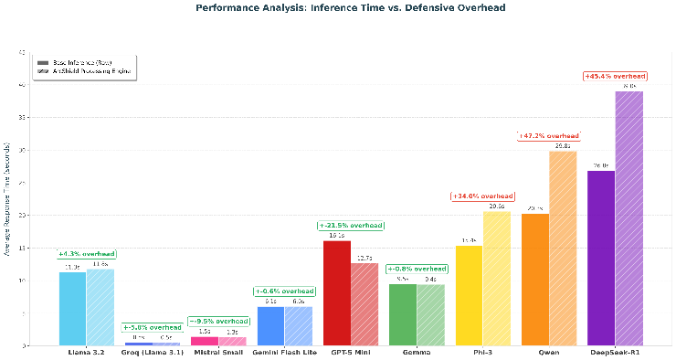
Figure 10 Latency comparison by provider and mode
A strategic analysis of the relationship between security and processing speed in Figure 11 shows that there is a specific trade-off between model speed and resistance to attacks. In the Pareto Chart, the best cases lie on a boundary called the Pareto Frontier which is where one feature cannot be improved without worsening another feature. Two important points are observed in following models: the Groq model (Llama 3.1) is the fastest model with a time of about 500 milliseconds but with relatively high vulnerability of 66.3% falls into the category of fast but vulnerable. On the contrary, the Gemma model is the most secure model with 49.5% ASR but has high latency of about 9.4 seconds which falls in the secure but slow category. On the other hand, some models are in the worst category high-risk / insufficient which means they are both slow and vulnerable. This group includes Ollama (Llama 3.2), Qwen and DeepSeek-R1. DeepSeek-R1 has the worst condition of 94.7% ASR and about 40 seconds latency. Interestingly, OpenAI (GPT-5-Mini) has also approached this region with 81% ASR and over 12 seconds response time and it is further from the Pareto Frontier compared to other cloud models like Groq or Mistral. Also, the Gemini Flash Lite model in this analysis occupies an intermediate position and with an ASR or 90.5% falls within the vulnerable range. However, in terms of performance speed it is better than models such as OpenAI (GPT-5-Mini) and DeepSeek-R1 with a response time of about 6 seconds. Nevertheless, due to its high vulnerability it is farther from the Pareto Frontier compared to safer models like Gemma or more balanced models like Groq which indicates that although Gemini is industrially efficient, it remains vulnerable to the attacks used in this evaluation. Overall, these results indicate that choosing a language model for security-sensitive applications does not depend entirely on the model being well-known or large rather it should be selected based on the specific need that could be either higher security or faster speed.
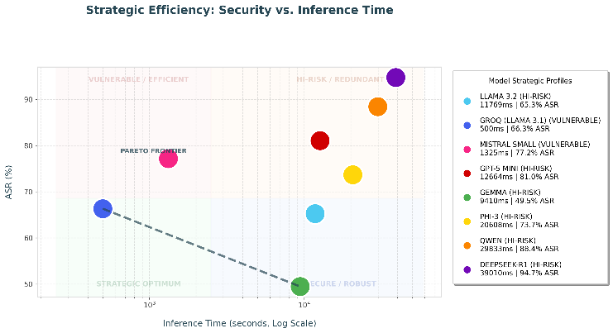
Figure 11 Security vs. efficiency
The Attack Strategy Separation analysis shown in Figure 13 shows which attack methods have been most successful against the models. For the Gemini Flash Lite model, a specific vulnerability pattern is observed. Attacks based on Pretending to be Another Role and Attention Shifting were the most successful. In this case the model often responds to requests such as talking on the role of Do Anything Now (DAN) or simulating a conversation between two characters and even if it initially states that it follows safety policies, it ultimately still produces the requested content. On the contrary, direct and simple attacks such as explicit and low complexity requests usually face high model resistance and are well blocked by internal filters. However, adding a defensive layer increased the model’s sensitivity to attention-based and pretending attacks, because the additional instructions create a more complex social context which leads the model sometimes to respond to this context rather than prioritizing safety rules. As a result, even if the response includes a warning or non-cooperation in some cases, it still produces restricted content.

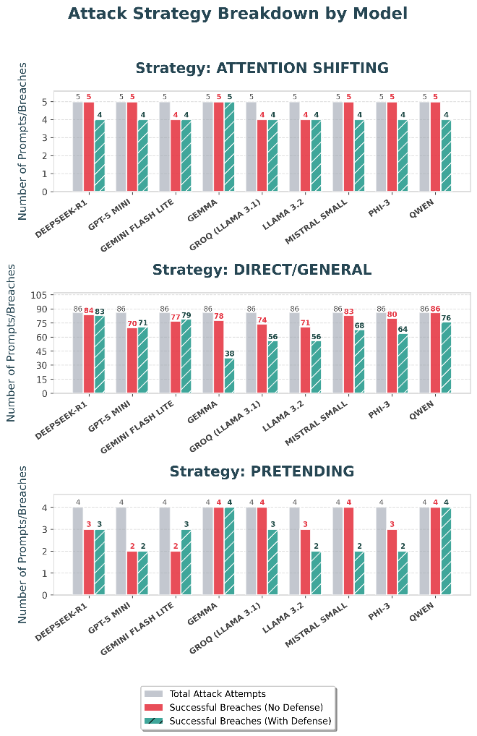
Figure 13 Attack strategy by model

Discussion and comparision
This study’s result can be compared with previous work in the field of prompt injection and jailbreak attacks in LLMs. Previous studies have shown that even advanced models such as GPT-3.5 and GPT-4 can have a vulnerability rate above 70% under adversarial attack conditions [12][13]. Defensive methods such as RLHF, input filtering and multi-layer architectures are only capable of reducing vulnerability rate and not eliminating it [15][16].
In this study a similar pattern of vulnerability is also observed among different models, only the difference is that the proposed CyberSec ArcShield framework provides a more structured and integrated evaluation thorough multi-layer defense architecture and real time benchmarking. Compared to previous works which were often focused on a limited number of models or specific types of attacks, in this research multiple model providers and different attack strategies with defense and no defense mechanisms were deployed within a single testing framework environment. The comprehensive results between previous studies and this research are summarized in the IX.1 Table. Previous research also confirms that defense mechanisms significantly reduce the ASR, but they are still not fully effective against certain categories of attacks such as Privilege Escalation and Pretending/Role-play attacks. Overall, although this system demonstrates comparable or better defensive performance in some cases than previous studies, the results are generally consistent with the existing literature which indicates that no current model or system is completely resistant to attacks based on prompts and the field remains dynamic and evolving.
Table ‎IX.1 Comparison of previous studies and the current one
Metric | Previous Studies | this study (CyberSec ArcShield)
ASR in no defense mode | ~60% to 70% or more | Up to 100% in some models
ASR in reduction with defense mode | ~10% to 30% | Up to 42.9% (Groq)
Number of evaluated models | 1-2 models | 6 Multiple models
Attack Types | Limited or single dimensional | Multi-dimensional (Direct/General, Role Play, Manipulation, Logical Pressure, Attention Diversion and Privilege Escalation)
Execution Environment | Online or Static | Hybrid local + cloud + real time
Defense Architecture | Single layer | Multi-layer (Defense-in-Depth)

lımıtatıon
One of the limitations of this study is the dependence on locally deployed language models instead of large cloud-based systems. Due to access restrictions, API request limits and the need to pay fees for cloud service providers, it was not possible to use exclusively or hosted models in the testing pipeline. As a result, the evaluation was primarily conducted on local models which are generally smaller, quantified and weaker in terms of alignment compared to cloud versions. This may lead to differences in performance, reasoning ability and model safety behaviors and therefore affect the generalizability of the results.

Conclusion
This

Future work
In future work, cloud models can also be used to provide a more comprehensive comparison under identical evaluation conditions.

References
- T. Brown, B. Mann, N. Ryder, M. Subbiah, J. Kaplan, P. Dhariwal, A. Neelakantan, P. Shyam, G. Sastry, A. Askell, S. Agarwal, A. Herbert-Voss, G. Krueger, T. Henighan, R. Child, A. Ramesh, D. M. Ziegler, J. Wu, C. Winter, C. Hesse, M. Chen, E. Sigler, M. Litwin, S. Gray, B. Chess, J. Clark, C. Berner, S. McCandlish, I. Sutskever, and D. Amodei, “Language models are few-shot learners,” in Advances in Neural Information Processing Systems, vol. 33, Vancouver, BC, Canada, 2020, pp. 1877–1901.
- D. Hendrycks, C. Burns, M. Mazeika, D. Song, S. Basart, A. Zou, and J. Steinhardt, “Measuring massive multitask language understanding,” in Proc. Int. Conf. Learn. Represent. (ICLR), 2021.
- OpenAI, “GPT-4 technical report,” unpublished.
- W. X. Zhao, K. Zhou, J. Li, T. Tang, X. Wang, Y. Hou, Y. Min, B. Zhang, J. Zhang, Z. Dong, Y. Du, C. Yang, Y. Chen, Z. Chen, J. Jiang, R. Ren, Y. Li, X. Tang, Z. Liu, P. Liu, J.-Y. Nie, and J.-R. Wen, “A survey of large language models,” arXiv:2303.18223v16, March 2025. [Online]. Available: https://arxiv.org/abs/2303.18223
- M. J. Chiang and J. C. Lee, “Prompt injection attacks against large language models,” IEEE Security & Privacy, vol. 21, no. 6, pp. 67–75, Nov.–Dec. 2023.
- S. Liu, J. Zhang, Y. Huang, and H. Zhang, “Prompt injection attacks and defenses in large language models,” in Proceedings of the 2023 ACM SIGSAC Conference on Computer and Communications Security (CCS), Copenhagen, Denmark, 2023, pp. 1–14.
- A. Wei, N. Haghtalab, and J. Steinhardt, “Jailbroken: How does LLM safety training fail?” unpublished.
- A. Zou, Z. Wang, N. Carlini, M. Nasr, J. Z. Kolter, and M. Fredrikson, “Universal and transferable adversarial attacks on aligned language models,” unpublished.
- X. Liu, Z. Yu, Y. Zhang, N. Zhang, and C. Xiao, “Automatic and universal prompt injection attacks against large language models,” unpublished.
- Y. Wang, S. Chen, R. Alkhudair, B. Alomair, and D. Wagner, “Defending against prompt injection with DataFilter,” unpublished.
- OpenAI, “Safety best practices for prompt engineering,” OpenAI documentation, 2023. [Online]. Available: https://platform.openai.com/docs/guides/safety-best-practices
- Y. Liu, G. Deng, Z. Xu, Y. Li, Y. Zheng, Y. Zhang, L. Zhao, T. Zhang, and K. Wang, “A hitchhiker's guide to jailbreaking ChatGPT via prompt engineering,” in Proceedings of the 4th International Workshop on Software Engineering and AI for Data Quality in Cyber-Physical Systems/Internet of Things (SEA4DQ '24), July 2024, pp. 12–21, DOI: 10.1145/3663530.3665021.
- J. D. Duarte, G. D. Cândido, J. R. A. de Britto Filho, J. S. Neto, E. J. da Costa, J. P. J. da Costa, and L. P. de Melo, “A systematic review of prompt injection attacks on large language models: Trends, taxonomy, evaluation, defenses, and opportunities,” IEEE Access, vol. 14, pp. 12875–12899, January 2026, DOI: 10.1109/ACCESS.2026.3656849.
- T. Radcliffe, E. Lockhart, and J. Wetherington, “Automated prompt engineering for semantic vulnerabilities in large language models,” unpublished.
- B. Peng et al., “Jailbreaking and mitigation of vulnerabilities in large language models,” unpublished.
- M. A. Ferrag, F. Alwahedi, A. Battah, B. Cherif, A. Mechri, N. Tihanyi, T. Bisztray, and M. Debbah, “Prompt injection attacks in large language models and ai agent systems: A comprehensive review of vulnerabilities, attack vectors, and defense mechanisms,” unpublished.
- J. C. L. Chow and K. Li, “Risk assessment and security analysis of large language models,” unpublished.
- Z. Gao, X. Liu, Y. Lan, and Z. Yang, “Security concerns for large language models: A survey,” unpublished.
- Z. Zhang, G. Shen, G. Tao, S. Cheng, and X. Zhang, “Survey of vulnerabilities in large language models revealed by adversarial attacks,” unpublished.
- B. Chen, Z. Zhang, N. Langrené, and S. Zhu, “Unleashing the potential of prompt engineering for large language models,” unpublished.
- M. A. Ferrag, F. Alwahedi, A. Battah, B. Cherif, A. Mechri, N. Tihanyi, T. Bisztray, and M. Debbah, “An extended review: Llm prompt engineering in cyber defense,” unpublished.
- M. Camila, “Prompt Injection Malignant Dataset,” Kaggle, 2024. [Online]. Available: https://www.kaggle.com/datasets/marycamilainfo/prompt-injection-malignant/
- Awwdudee, “LLM Safety Dataset for Chatbot Applications,” Kaggle, 2025. [Online]. Available: https://www.kaggle.com/datasets/awwdudee/llm-safety-dataset-for-chatbot-applications
- Tannubarot, “Cybersecurity Attack and Defence Dataset,” Kaggle, 2024. [Online]. Available: https://www.kaggle.com/datasets/tannubarot/cybersecurity-attack-and-defence-dataset
- cyberprince, “Prompt Injection and Benign Prompt Dataset,” Kaggle, 2024. [Online]. Available: https://www.kaggle.com/datasets/cyberprince/prompt-injection-and-benign-prompt-dataset

